Sumama Rahim
F24BSCS039 [Company address]
Database systems Lab 06 Task Report

Q. 1: The minimum salary being paid to any faculty member.
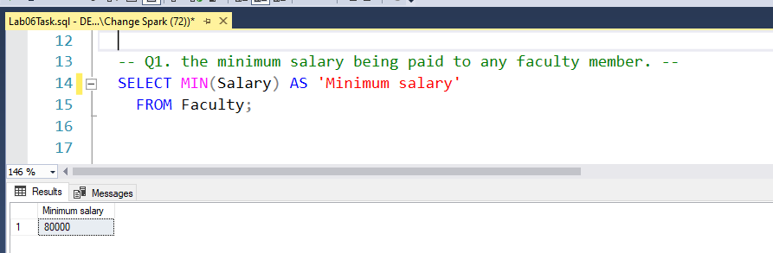
Q. 2: The maximum salary being paid to any faculty member.

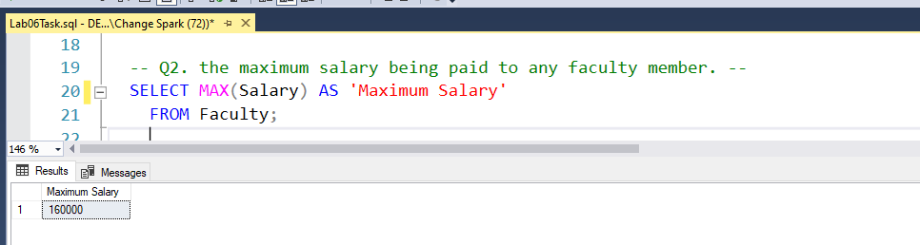

Q. 3: the employee who is being paid the highest salary in the university.
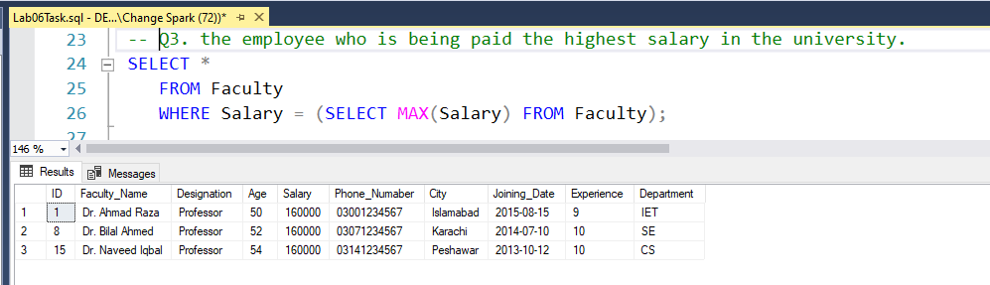
Q. 4: the lecturer who is being paid the lowest salary in the CS department.
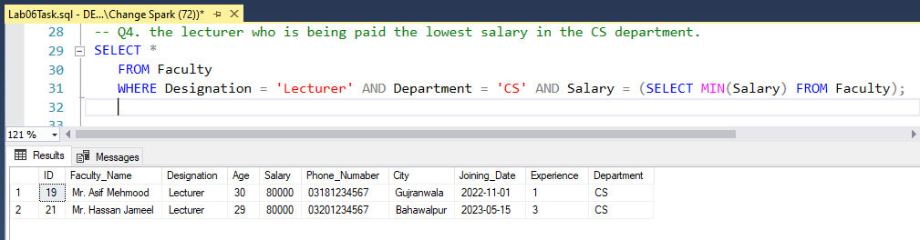
Q. 5: the minimum salary being paid to any Assistant Professor.
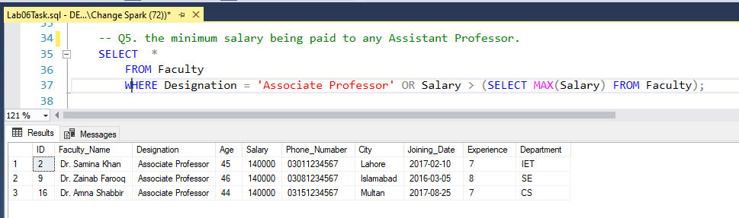
Q. 6: the total number of faculty members of the university.
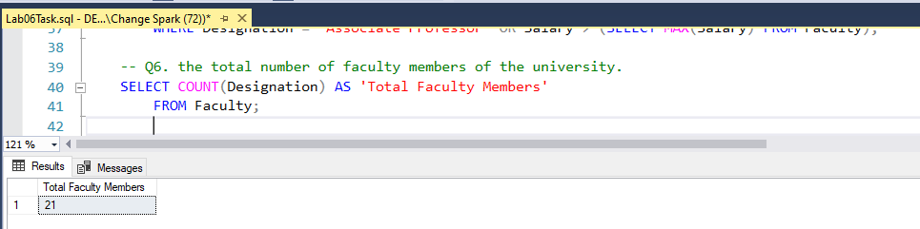
Q. 7: the total number of Lecturers serving in the university.
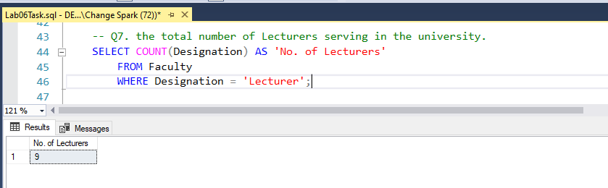
Q. 8: the total number of faculty members from Islamabad.
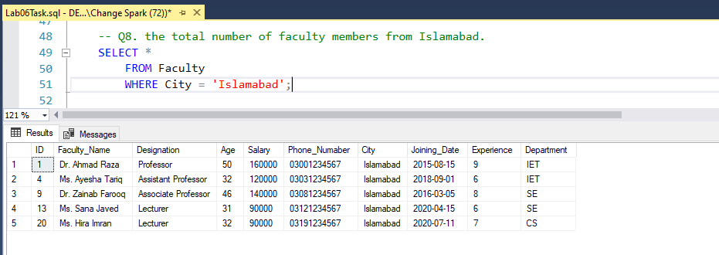
Q. 9: the names of cities from which different faculty members belong.
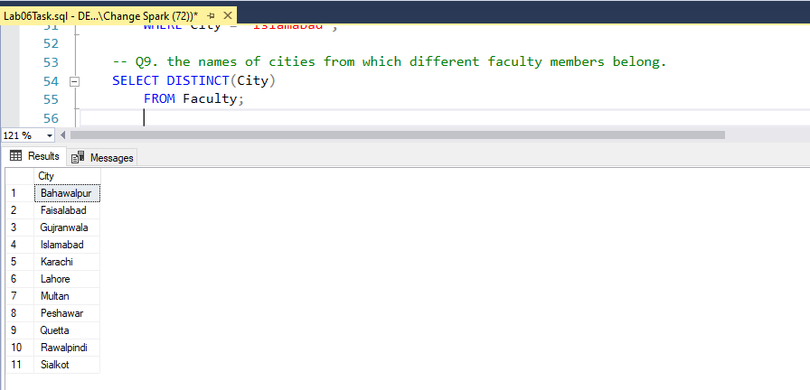
Q. 10: the total amount of salary being paid to all faculty members.
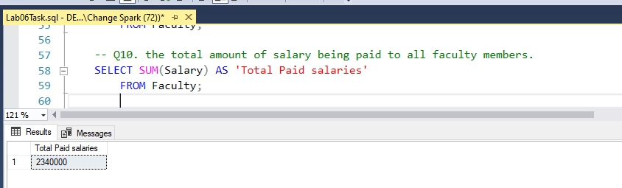
Q. 11: the total salary being paid to professors of the university.
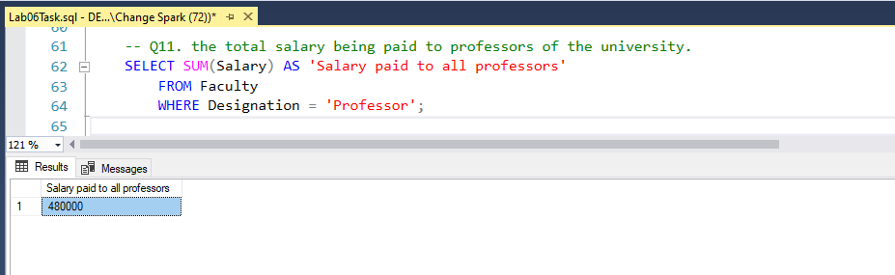

Q. 12: the total salary being paid to lecturers of the IET department.
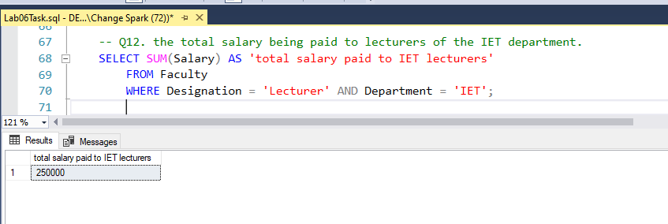
Q. 13: the annual salary being paid to an Associate Professor.
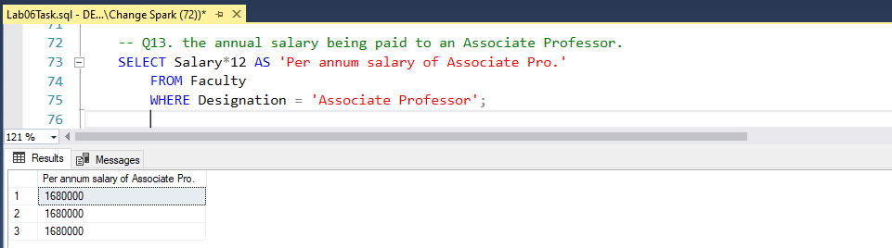

Q. 14: the faculty members who are earning more than the average salary of all employees
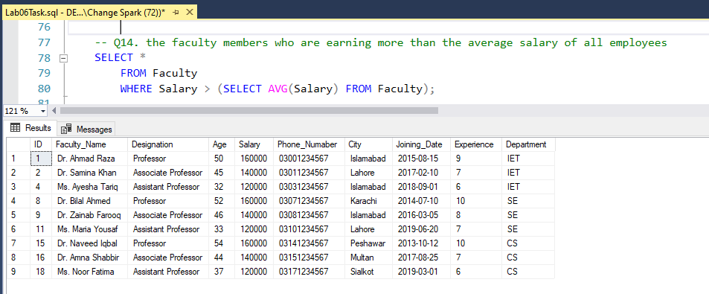
Q. 15: one professor, one AP, and one lecturer joined the IET department in 2023, calculate the annual increment of the salary budget of the IET department.
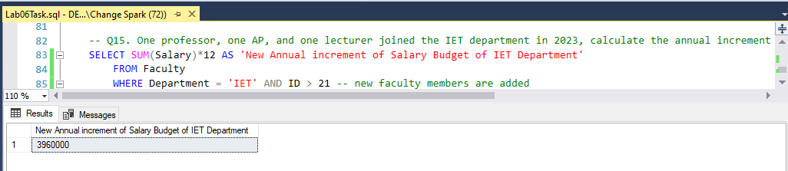
Q. 16: show the faculty members and their joining date in the format "day, Month date, year" who will retire in the next 5 years if the retirement age is 60
